<https://developer.mozilla.org/zh-TW/docs/Glossary/Callback_function>

greeting(name) {

alert("Hello " + name);

}

function processUserInput(callback) {

var name = prompt("輸入你的名字：");

callback(name);

}

processUserInput(greeting);

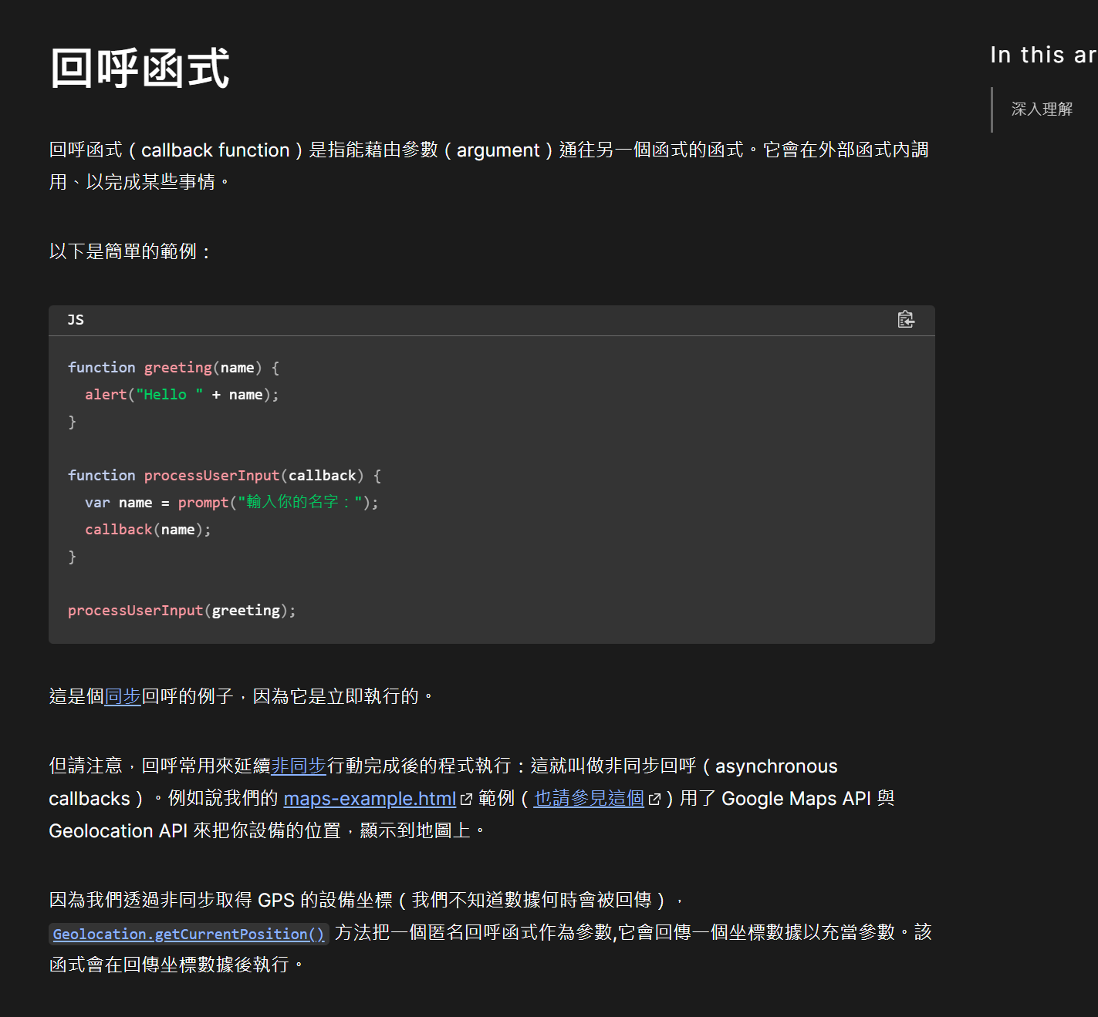

<https://www.youtube.com/watch?v=8ttVuW2sK68&ab_channel=CodeShiba%E7%A8%8B%E5%BC%8F%E6%9F%B4>

範例2

